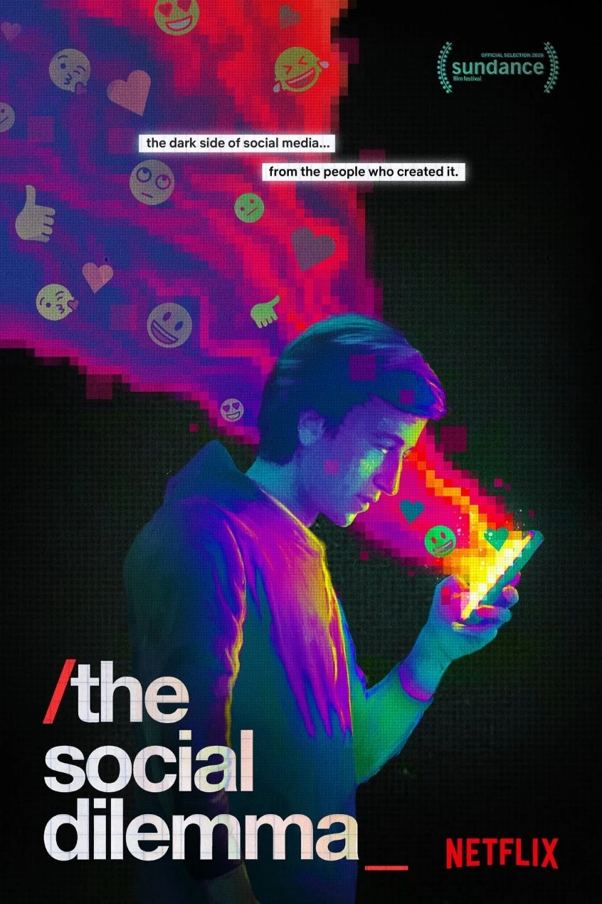

Chavarria, Ronan;

Oliveros, Sheena Violy; Santos, Benedict Christian; Ugay, Christian

**Activity # 1: Documentary Film Review (Social Dilemma)**

**I. Introduction and Summary**

Our group was tasked with reviewing the documentary The Social Dilemma," it was a thought-provoking documentary film directed by Jeff Orlowski who was known to make films or documentaries relating to the crisis our society is going through. The documentary delves deep into the dark side of social media technology companies that handle it and exposes how companies and the technology behind it can or are used to manipulate and make their users dependent on their platforms using their out-of-this-world algorithms. The documentary presents a compelling case that will leave you questioning your social media habits and their impact on society, mental health, the political landscape, and the overall condition of our society.

The documentary starts by explaining its points through the eyes of tech experts and former employees of known top tech companies, the documentary explores and explains the psychological root of technology addiction and its relation to the methods tech companies use to monetize user data and attention in which the documentary explained that it can be used to manipulate or affect the psychological state of the user’s who use the platform. The film features interviews with former executives and designers from companies such as Google, Facebook, and Twitter, who explain the psychological techniques and manipulation tactics used to keep users addicted to their platforms. The film also includes a dramatized narrative of a family dealing with the negative effects of social media addiction. The documentary highlights the dangers of fake news, mental health issues, and the influence of artificial intelligence on social media. It concludes with suggestions for ways in which individuals can take action to fight back against the negative effects of social media.

**II. Analysis**

Jeff Orlowski the director of “The Social Dilemma” also directed several documentaries Chasing Corals (2017) and Chasing Ice (2012) which won an Emmy award, that earn him a reputation for making documentaries that raises public awareness to important social and environmental issues. This background can have implications for the accuracy of The Social Dilemma, as it could suggest a bias towards alarmism and a tendency to oversimplify complex issues.

The documentary presents several arguments regarding the detrimental effects of social media on people and society. These allegations cover the following topics: algorithmic user behavior manipulation, dissemination of false information and fake news, erosion of privacy, and detrimental effects on mental health. The film also makes the case that social media businesses put user welfare below profit, creating a moral and ethical crisis. While the claims made in The Social Dilemma documentary have been criticized for being oversimplified and lacking nuance, there is some evidence to support the idea that social media algorithms can have negative effects on users. As they cited several sources to support their claim studies on the impact of social media use on mental health, as well as interviews with former executives from major social media companies. Some critics argue that the documentary ignores research that contradicts its thesis and cherry-picks material to support its conclusions and that the movie uses sensationalism rather than a fair investigation of the subject to give a skewed image of the social media industry and its effects on society.

The film's lack of balance has been criticized it presents a one-sided view of the issue and ignores the nuances of the debate. The Social Dilemma has sparked significant debate about the accuracy of its claims and the bias of its director. While the documentary raises valid concerns about the impact of social media, it is essential to consider the positive aspects of these platforms and to acknowledge the complexities of the issue. Ultimately, documentaries like The Social Dilemma have a critical role to play in raising public awareness of pressing issues, but accuracy and balance are essential to ensuring that they do not contribute to the spread of misinformation.

**III. Creative Elements**

One of the creative elements of the film includes a lot of interviews with various tech industry insiders, creators, designer, and experts, such a Tristan Harris, a former design ethicist from google and the co-founder of the center for humane technology; Jaron Lanier, Tim Kendall, and others. These well established tech experts provided insights into the negative effects of social media in our society. On the flip side, the film also made use of fictional characters, the main character Ben, his family and the A.I., to further illustrate how social media affects teenagers.

The interviewees engage in a dialogue about the problems facing the technology industry and the impact of social media on society. They discuss a range of issues, including the addictive nature of social media, the impact on mental health, the role of algorithms and artificial intelligence in decision-making, and the impact on democracy.

The camera work in the documentary was mostly close-ups of the experts' faces as they shared their experiences. This really helps to further connect with them and their insights to evoke emotions from the audience.

The film is a documentary drama, with a serious and urgent tone, that encourages the viewers to exercise critical thought regarding their use of technology by highlighting the possible risks associated with social media and the algorithms that power it. In the film, one of the symbols they used is the visualizations of algorithms and data by turning them into humans appearing to be working for these tech industries who analyze the main character’s use of social media and ways to re-engage to keep him locked to his screen, ultimately highlighting the impact of social media on people's lives.

**IV. Opinion**

**1) Advertisers are the customers, we’re the thing being sold**

The movie explains well that we are being sold to big tech companies but doesn’t full explain some of the implications of signing up to a certain social media. Businesses may collect consumer data and use it to power better customer experiences and marketing strategies. They may also sell this data for revenue. Even though companies like Facebook and Google aren’t directly selling your data, they are using it for targeted advertising, which creates plenty of opportunities for advertisers to pay and get your personal information in return. In this process, the audience becomes commodity that is sold to advertisement.

By the given issue, we do not agree because first of all its unethical. Its against to Data Privacy Regulations and also to users. This dynamic is particularly evident in the online world, where personal data is often collected and sold to advertisers to better target their ads. This creates a conflict of interest, as platforms may prioritize the needs of advertisers over the needs of their users. Intentionally failing to articulate how you are data-mining service usage and user data.

**2.) Addiction to social media**

To quote in the documentary “there are only two industries that call their customers users, illegal drugs and software”, the film point out that there’s an alarming increase on the number of user who rely to much on the said social media platforms.

We agree to the statement, as a part of the current generation who first-hand experience the exemplary changes on the platform we use to socialize there’s no denying the platform have become somehow addicting and time consuming

**3.) Effects of social media to people (emphasis on children usage)**

We agree that there’s plenty of social media effects and some of them can cause negative impacts, especially on the children of this current generation who've been exposed to the technology earlier. Like what the film shows where they portray a family having dinner and can barely socialize with each other without looking at their devices. However there’s various positive effects social media has brought to us and our children too, like connecting to each other has become easier and convenient, entertainment is only one touch away..

**4)** **Age of disinformation and fake news**.

The age of disinformation and fake news is a growing concern today, as evidenced by the prevalence of misinformation spread through social media platforms. The documentary "The Social Dilemma" highlights the ways in which social media algorithms are designed to prioritize engagement and maximize profit, often at the expense of truth and accuracy. This creates a dangerous cycle of misinformation that can have real-world consequences, from undermining democratic institutions to exacerbating social divisions and public health crises. We agree that social media plays huge role creating the age of disinformation, as such it is essential that individuals, media organizations, and tech companies take steps to combat fake news and promote a more responsible and trustworthy information.

**V. Conclusion**

**"**The Social Dilemma" is a 2020 docudrama that explores the negative effects of social media on society, particularly regarding the manipulation of user behavior for profit. The film highlights the alarming impact of social media on mental health, privacy, and democracy and suggests that social media companies have a significant responsibility to address these issues. One key conclusion that can be drawn from the film is that social media companies prioritize profits over the well-being of their users. The algorithms and design features used by these companies are intentionally crafted to keep users engaged and addicted to their platforms, leading to negative consequences such as addiction, polarization, and the spread of misinformation. The film also suggests that social media companies have an outsized impact on shaping public opinion, particularly in the context of elections and political discourse.

We think that the film is relevant to both those who use technology and those who are merely studying it. The characters also reflects to those people deal with it, for instance the teen girl who active in social media gets cyberbullied by her fellow teens. And the film mentions this as one of the problems. This movie's main message is that we need to use all of this technology in the. The power dynamics at play between social media companies, advertisers, and users are complex and raise significant concerns about the potential for democratic erosion and the manipulation of public opinion.

Despite the criticism, we believe that the filmmaker of the documentary succeeded in his intention of raising awareness of the negative effects of social media. It served as a call to the risks of social media dependency and the strength of algorithms to manipulate our behavior. It encourages us to think critically about our use of social media and how it affects our lives. As a student of application development and new technologies, the documentary has helped us apprehend the significance of thinking about the ethical implications of technology development. It encouraged us to be more conscious of our social media use and how it affects our mental health and well-being. It has also made us aware of the potential negative impact technology can have on society and how we can work to mitigate those impacts.

Finally, "The Social Dilemma" emphasizes the urgent need for policymakers, tech experts, and users to take collective action to address the negative impact of social media on society. The film suggests that this requires a comprehensive approach that includes regulatory measures, user education, and industry-wide changes in business models and design features. Ultimately, the film serves as a call to action for society to reevaluate our relationship with social media and take steps to ensure its impact on our lives is positive and constructive.

Overall, the documentary was an eye-opening experience. It shows us how social media can be exploited to harm or manipulate a user without them even noticing it, and the urgent need for an intervention to limit or regulate the amount of impact the social media algorithm can have on its user before irreversible consequences happen. The documentary shows their points clearly by providing statements from professionals who had first-hand experience with the problem and even providing a drama showcasing how a typical family can be affected by the said problems. As a student who’s aspiring to create a program that will help and serve many people, this documentary serves as a new realization to me that our roles do not end with designing and creating the program but also extend to making sure that our creation will not be used in wrongdoing.

**VI. Relevance to the Course**

The Social Dilemma is closely related to application development and emerging technologies in our particular course because of the fact that it involves technology, and it addresses problems in the documentary film that are relevant in today’s day and age in more ways than one, it introduced these issues and drawbacks of the technologies we thought we once knew to have more benefits than harm, and addresses the steps we need to take to escape these complications.

Application development is the process of developing a computer program or a collection of applications to carry out the many activities needed by a business. Moreover, frameworks offer a methodical approach to the app development process. It is in line with this course since the development of software applications fosters critical thinking and the creation of vital applications address the problems raised in the documentary film.

Although the word "emerging technology" is typically used to describe a new technology, it can also apply to an existing technology that is still being developed. It represents a development in technology. As we live in a time where everyone uses a device for work, school, leisure, advertising, and other purposes, we are powerless to stop the advancement of technology. The workforce of emerging technologies, which is in high demand to make things faster, easier, and give us more free time, has a significant impact on our society. Yet it can also alter how society thinks. The Social Dilemma warns us about the intrusion and manipulation of one another's lives by developers of major tech companies. It is educating us on how to use technology properly. For instance, when we play online games, those games are made to be fun, relaxing, and enjoyable for us. Nevertheless, if the game isn't making you happy, content, or enjoyable, it's manipulating your feelings in order to make it worse.

This movie has a great influence on me as a student taking this course. We research anything relating to the history of technology, codes, and computer systems. It made us want to understand more about these problems and how to reduce them. To create a better society, we can conduct early research on this problem.

The movie teaches us that we need to modify the way we use technology and spend our time living rather than watching it. Technology was developed to ease our lives, not to rule them. Beyond the screen, life is waiting.